**CSA1054 Software Engineering**

**LAB EXPERIMENTS (DAY 2)**

**NAME: K. Siva Naga Manoj Kumar**

**Reg number: 192111630**

**EXPERIMENT NUMBER 1:** Draw an Activity diagram for Hospital Management System using CASE tools with Familiarizing activity Diagram Components, parts that are used to make the diagrams which determine the targeted users. Analyse the activities included plot of Hospital, Patient, Doctor, Receptionist the relationship. Show how the user, the hospital staff, can interact with the system model.

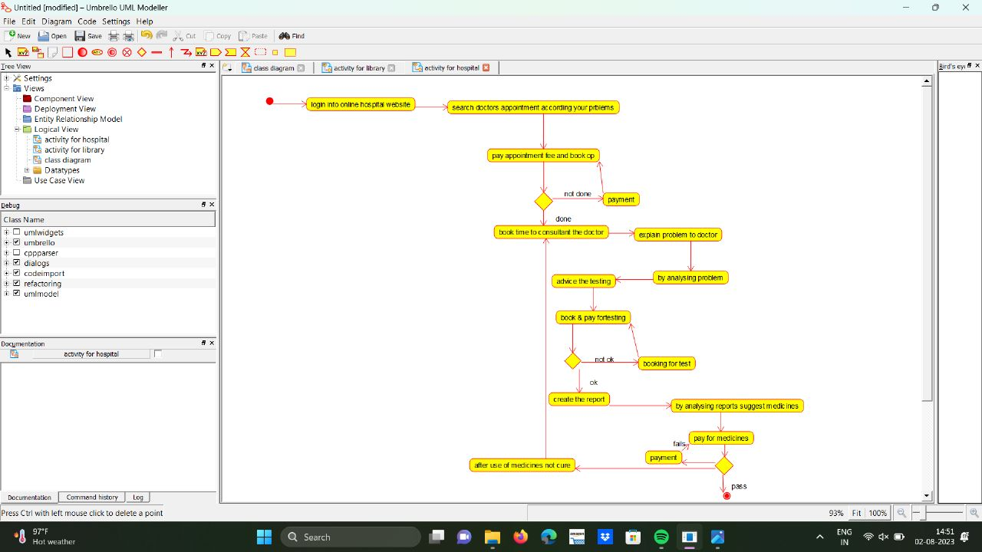

**EXPERIMENT NUMBER2:** Draw a Activity diagram for Library Management System using CASE tools constructing User who registers himself as a new user initially who is regarded as staff or student. After getting the library card, a new book is requested by the user. After, requesting, the desired book issue the book to the user. Renew the book if the user needs the book again. Add the agent as Librarian and the user in the activity diagram

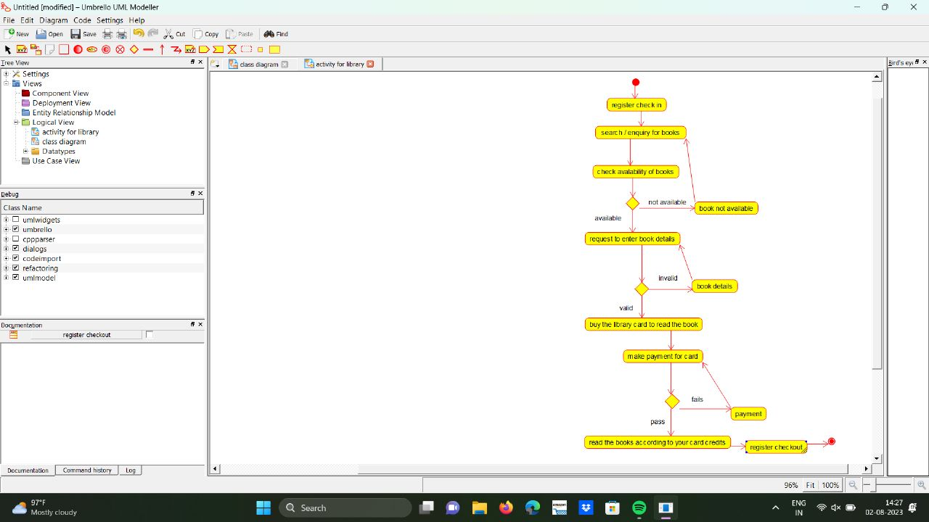

**EXPERIMENT NUMBER3:** Make an Online Airline Reservation System. The activities of the Online Airline Reservation system are listed below user, admin, LOGIN, MANAGE CLASSES, MANAGE WAITING LIST, MANAGE HOLDS, MANAGE DEADLINES, LOGOUT, using this has a step-by-step process draw a CLASS diagram Draw a Class diagram for Library Management System using CASE tools.

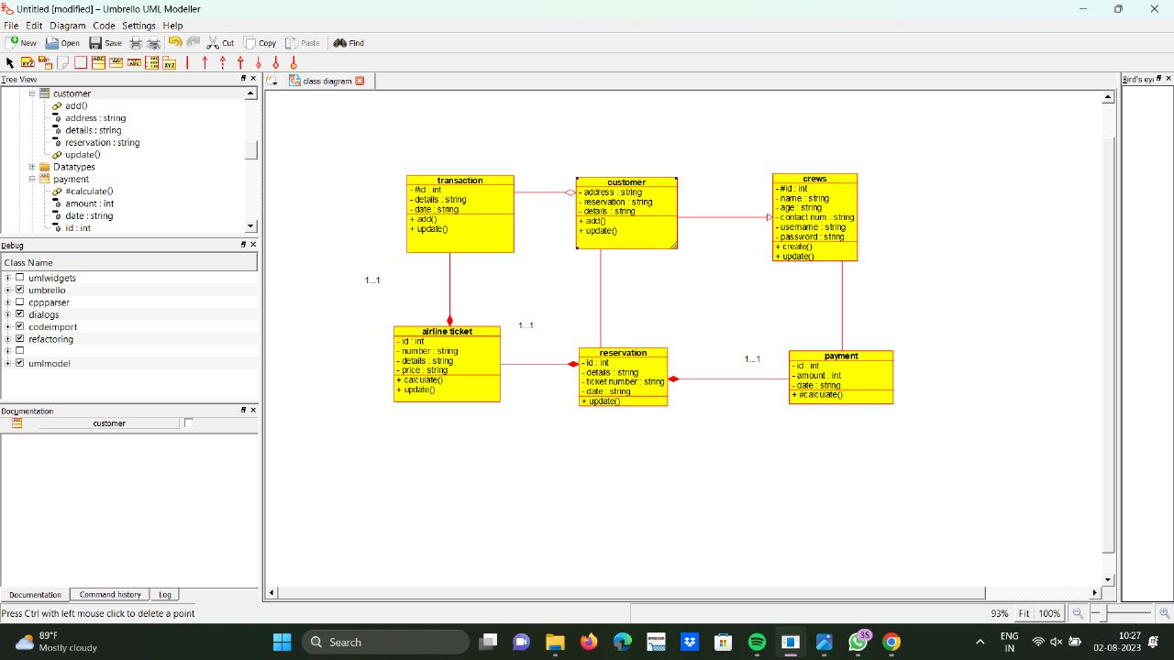

**EXPERIMENT NUMBER4:** Draw a Class diagram for Online Voting System using CASE tools. eVote is an election system that facilitates voters to record their secure and secret ballot electronically. It has a friendly user interface and enables voters to cast their votes in a few simple steps. We ensure the authenticity of the voters and the votes cast by them along with non-traceability of the casted vote elaborate the whole process of e-voting.

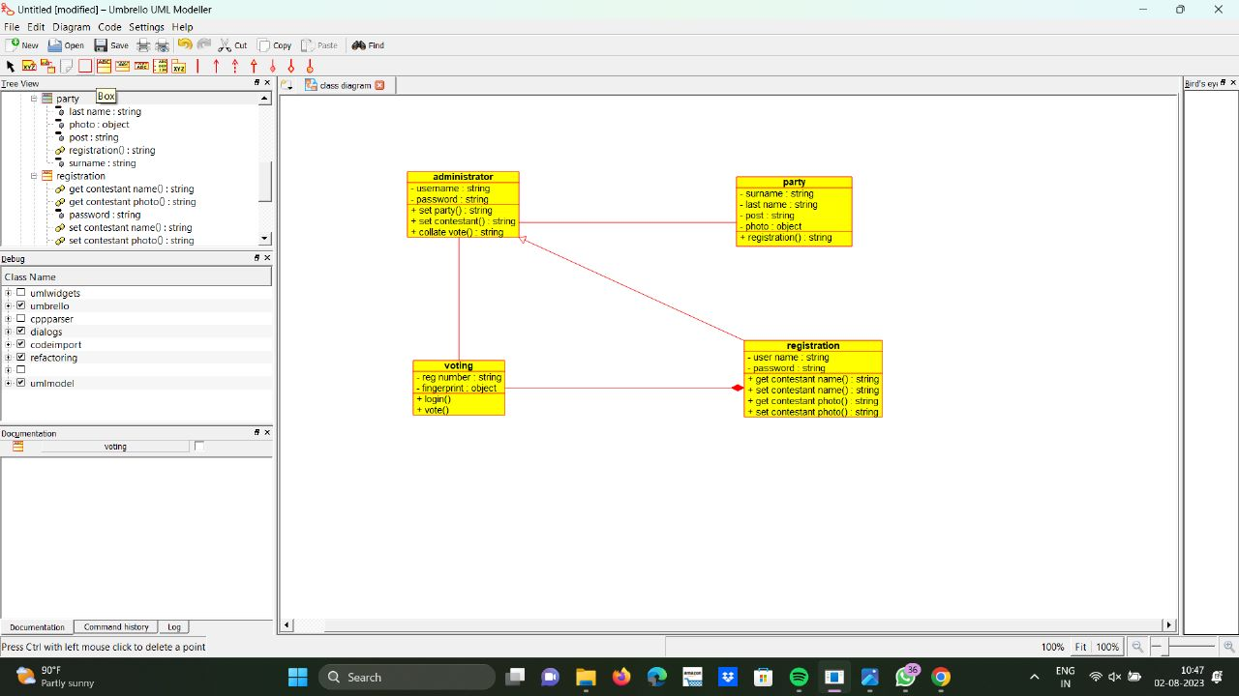

**EXPERIMENT NUMBER 5:** Draw a Class diagram for Library Management System using CASE tools. Designing use case diagram for the library management system. User who registers himself as a new user initially is regarded as staff or student for the library system. Librarians have a key role in this system. Librarian adds the records in the library database about each student or user every time issuing the book or returning the book, or paying a fine. Design the class diagram for this

